
Computer Systems Engineering Technology
CST 133 – Digital Logic II

Lab 01 – Designing a Full Adder Using Quartus Design Flow | Name: Yael Roque Mercado
Fall 2026 | Due Date: End of Lab Period
Instructor: Scevers
Possible Points: 100

Instructions
We will be using Quartus Prime Standard Edition to implement this lab. For simplicity, we will refer to this software package simply as Quartus. In this lab we will introduce the design of logic circuits using Quartus. Step-by-step instructions are presented for performing design entry with Verilog code. The lab also illustrates the design process and simulation of a Verilog program.

Getting Started
The first step of this lab will be to set up a Git repository to store all the labs we will be implementing this term. Please watch the video for help with getting started in git. You will need to create a repository called cst133. Once this is created and cloned to your machine you will need to add the .gitignore file from Canvas and check it into your repository. This must be at the root of your project.

Each logic circuit being designed in Quartus is called a project. The software works on one project at a time and keeps all information for that project in a single directory in the file system. To begin a new logic circuit design, the first step is to create a directory to hold its files. This file should be created in the repository from the previous step. Also note, Quartus does not like spaces in paths for its projects so please use a “-” or “_” if you must.

This tutorial presents an introduction to Quartus, the design flow, and Simulation. The flow involves the following steps.

- Design Entry – the desired circuit is specified by using a hardware description language, such as Verilog.
- Synthesis – the entered design is synthesized into a circuit that consists of the logic elements (LEs) provided in the FPGA chip.
- Simulation – the synthesized circuit is tested to verify its functional correctness.

First, we will need to start the Quartus software. You should see a window like the one in Figure 1. This display consists of several windows that provide access to all features of Quartus, which the user selects with the computer mouse. Most of the commands provided by Quartus can be accessed by using a set of menus that are located below the title bar.

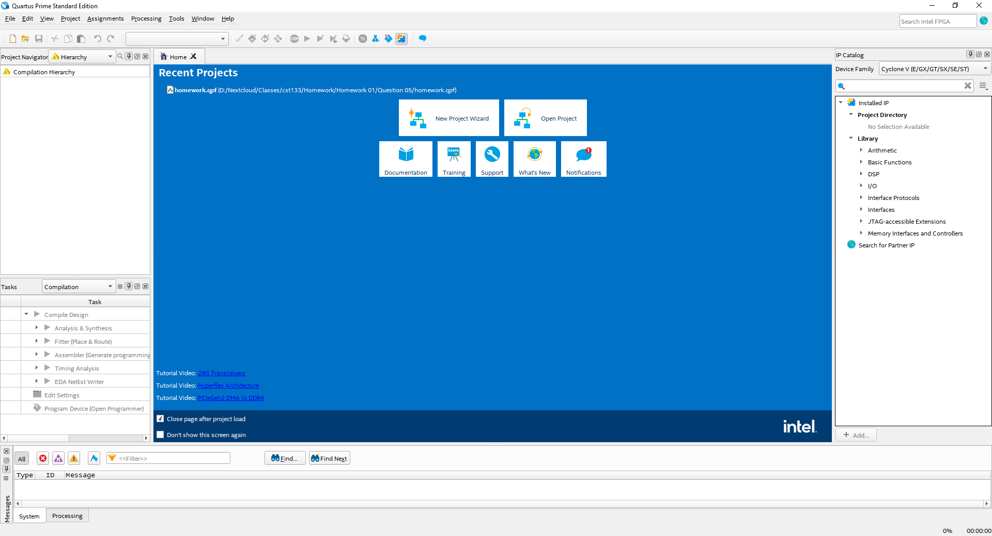

Creating a Project in Quartus
Figure 1 - Intel FPGA Quartus Prime Software
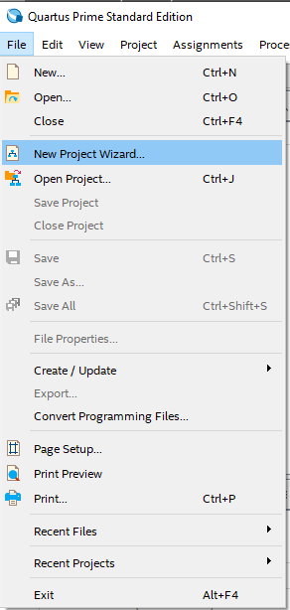
The first thing we need to do is click on the New Project Wizard menu item (There is also a link on the Quartus home screen) as shown in Figure 2. This will open the wizard for creating a project. We will walk through this process in this lab tutorial.
Figure 2 - New Project Wizard

The first screen of the “New Project Wizard” is the introduction screen. We can skip this screen as it does nothing to create the actual project. I would read through it the first time you create a project.

The next screen is the “Directory, Name, Top-Level Entity” window. On this screen of the wizard, we set our working directory for the project (Where everything will be stored). We also give the project a name and the name of the top-level entity for the project. If we were to analogize this with C++ this would be the file that contains the main() function.

Create a Lab01 folder under your repository (Make sure there are no spaces in this path). Set the working directory to this newly created directory. For the name of the project please type in “FullAdder”. Notice that you will add this name to the top-level entity section automatically. When finished you should have something like Figure 3. Note: The directory structure will be different as it should be under your git repository.
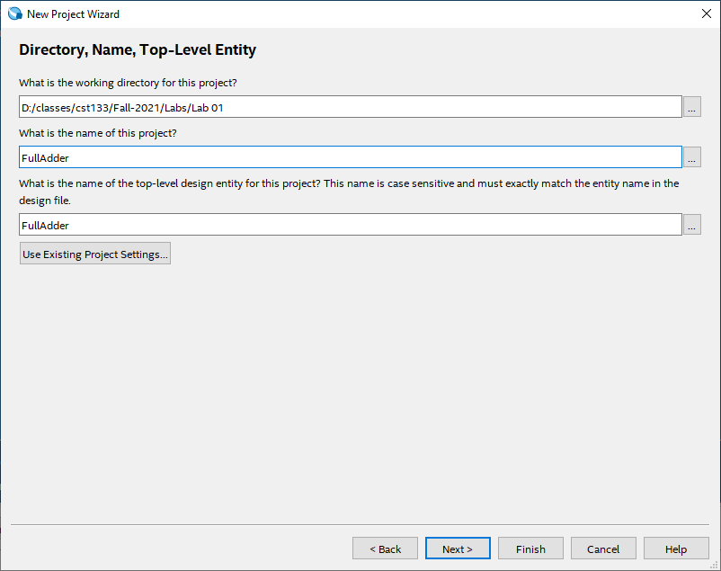
Figure 3 - Directory, Name, Top-Level Entity Screen

The next screen is the “Project Type” screen. Please select Empty project as shown in Figure 4.
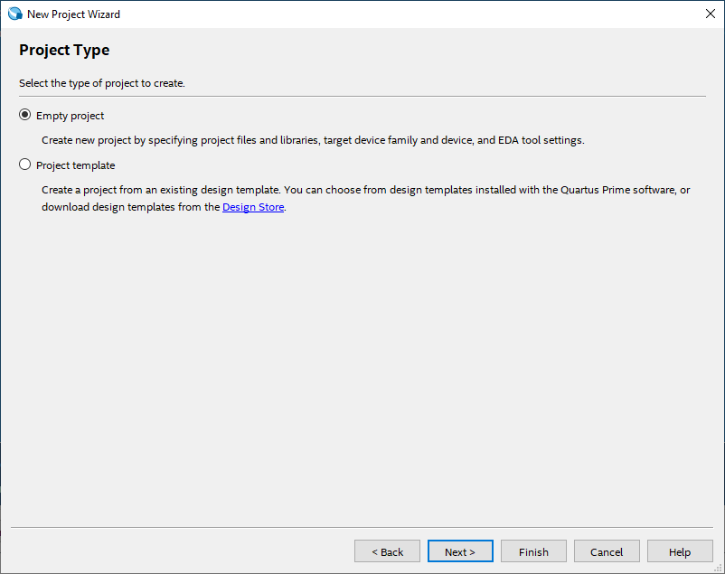
Figure 4 - Project Type Screen

This will bring you to the “Add Files” screen. For this screen we will just click next.

Now we arrive at the “Family, Device & Board Settings” screen. Click on the Board tab. Now under family select Max 10. Then under development kits select MAX 10 DE10 – Lite. Make sure the “Create top-level design file is unchecked. The screen should look like Figure 5.
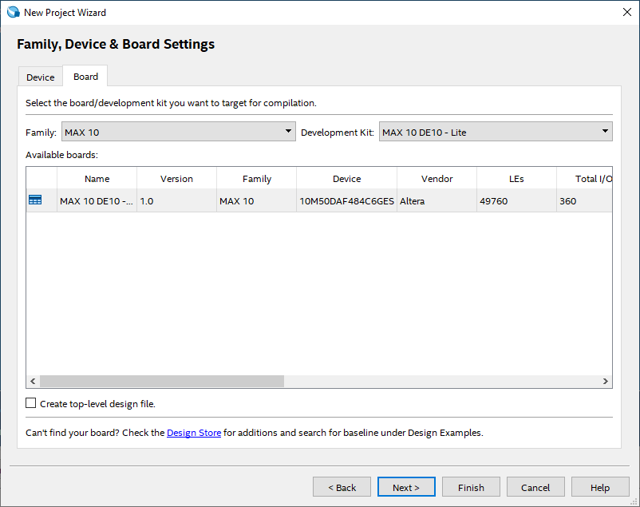
Figure 5 - Family, Device & Board Settings Screen

The next screen is the “EDA Tool Settings” screen. You will just click next on this one.

This will bring you to the final screen of the wizard the summary screen. Yours should be like the one shown in Figure 6.

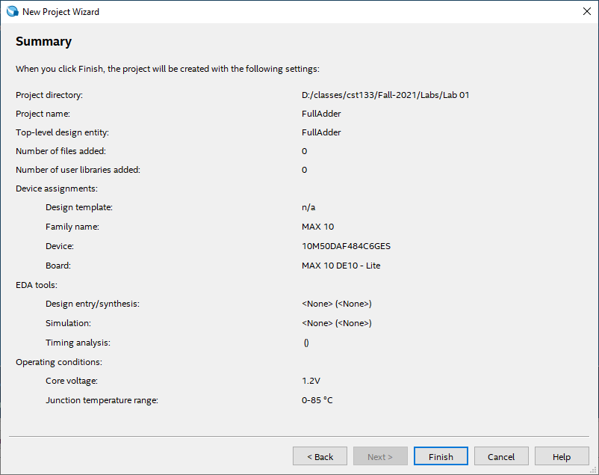
Figure 6 - Summary screen

After the wizard is complete you should see your Quartus window looking like the following.
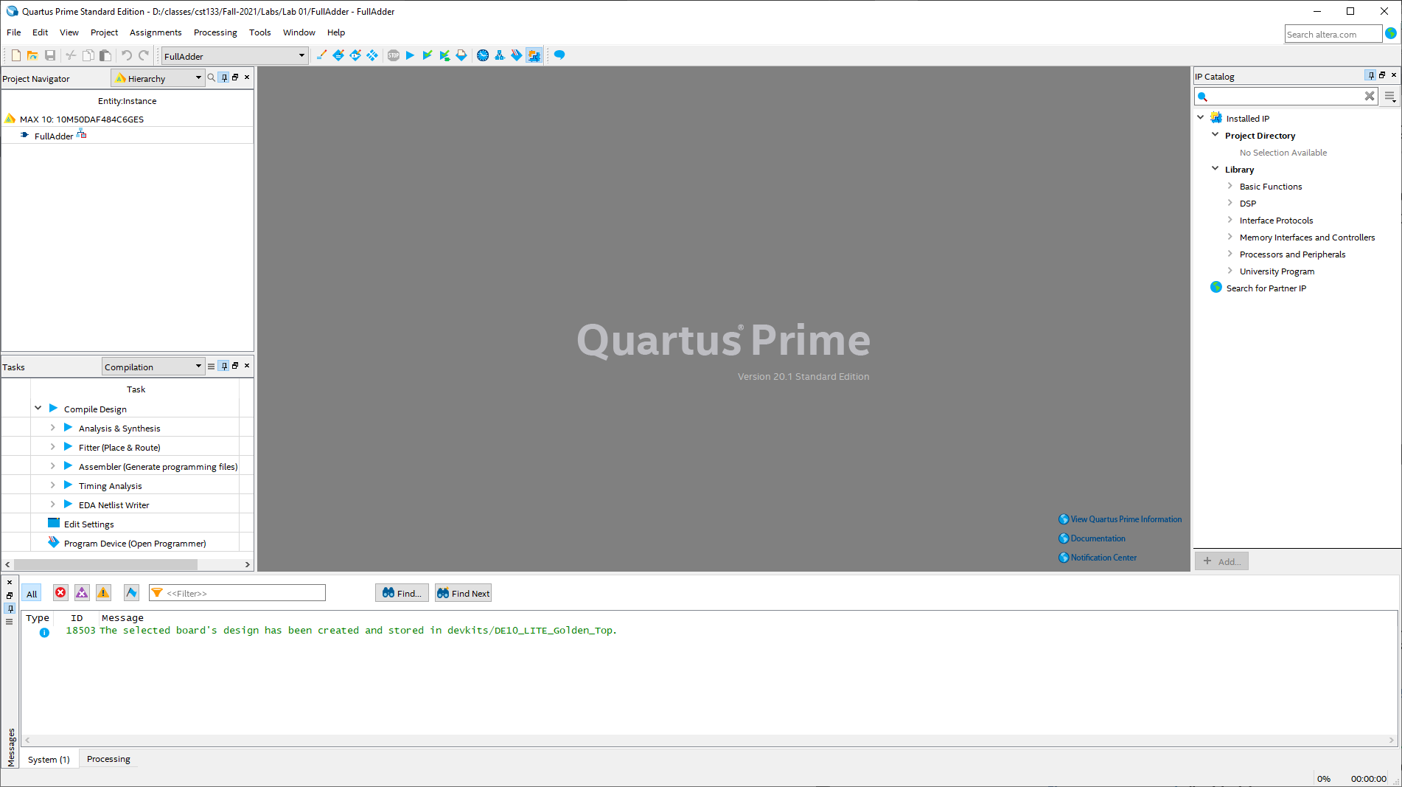
Figure 7 - Quartus after project creation

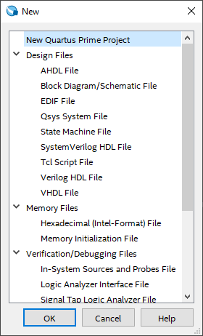
Adding or Top-Level entity Verilog code
Figure 8 - New File Window
Click on the “File” menu and select “New”. This will bring up the “New” window where we can choose what kind of file we are going to create as shown in Figure 8. You will need to select “Verilog HDL File” and click OK. Now we need to do click on the “File” menu and select “Save”. This will bring up the save dialog box. The box should be in our working directory and the save file name should already be set to FullAdder.v. Click the save button.

Now we need to enter our Verilog code. The code can be found in Code 1- FullAdder Verilog Code. Once the code is typed in please make sure and hit save again.

Code 1 - FullAdder Verilog Code
// <Student Name Here>
// Structural design for a full adder using Verilog
module FullAdder (
input A, B, Cin,
output Sum, Cout);

wire S1, T1, T2, T3;

// Structural code for 1-bit Full Adder
xor U1(S1, A, B);
xor U2(Sum, S1, Cin);

and U3(T3, A, B);
and U4(T2, B, Cin);
and U5(T1, A, Cin);

or U6(Cout, T1, T2, T3);
endmodule

Compiling the code
The next step is to compile the design. This will run through several modules: Analysis & Synthesis, Fitter (Place & Route), Assembler (Generate programming files), and Timing Analysis. To start this process, click the “Processing” menu and select “Start Compilation”. Note: you can also select the “Start Compilation” tool from the toolbar. When compilation is finished you should have a screen that looks like the one shown in Figure 9.
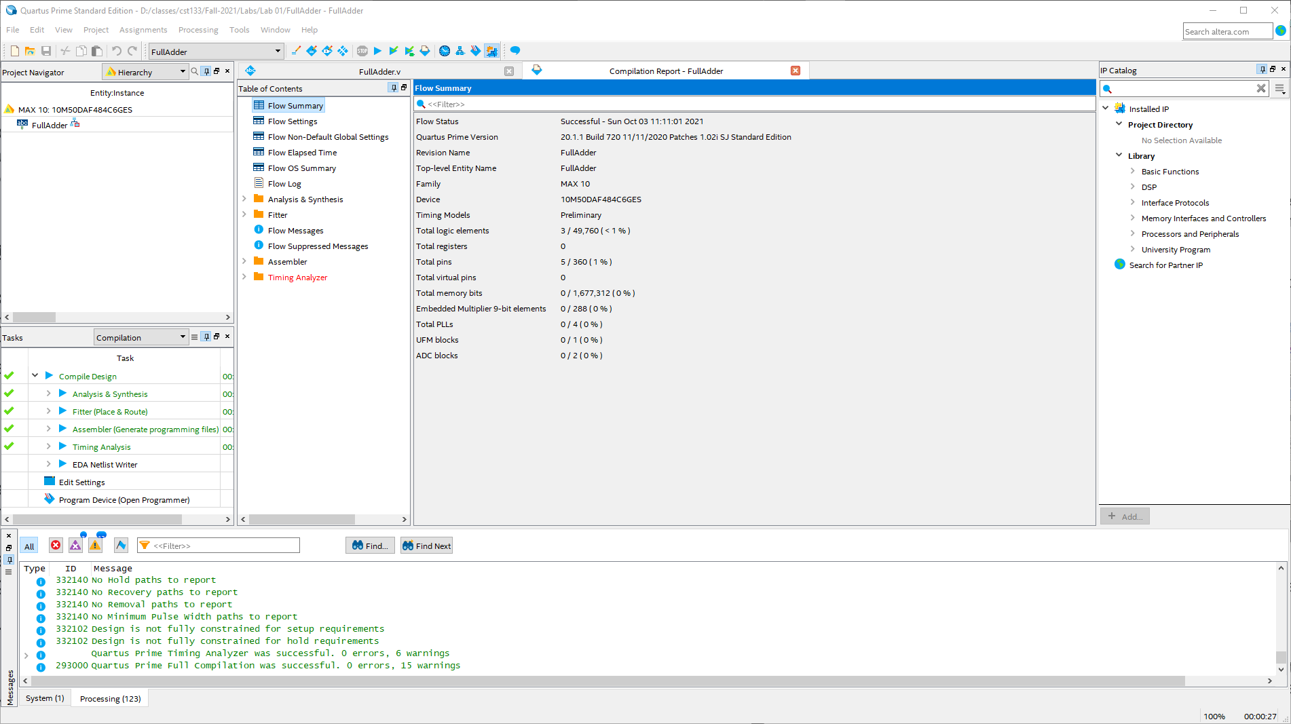
Figure 9 - Quartus window after compilation

Functional Simulation
To start we will need to add a new file to our project. Select the “File” menu and click “New”. Under the New window select “University Program VWF” under the “Verification/Debugging Files”. Save this file to your design but call it “waveform.vwf”. Edit the Grid Size of the waveform window to be 60 ns. Select The “View” menu and press the “Fit to Window”. Now it’s time to insert the Nodes into the window. Right click on the left side of the waveform window and select “Insert Node or Bus” as shown in Figure 10.
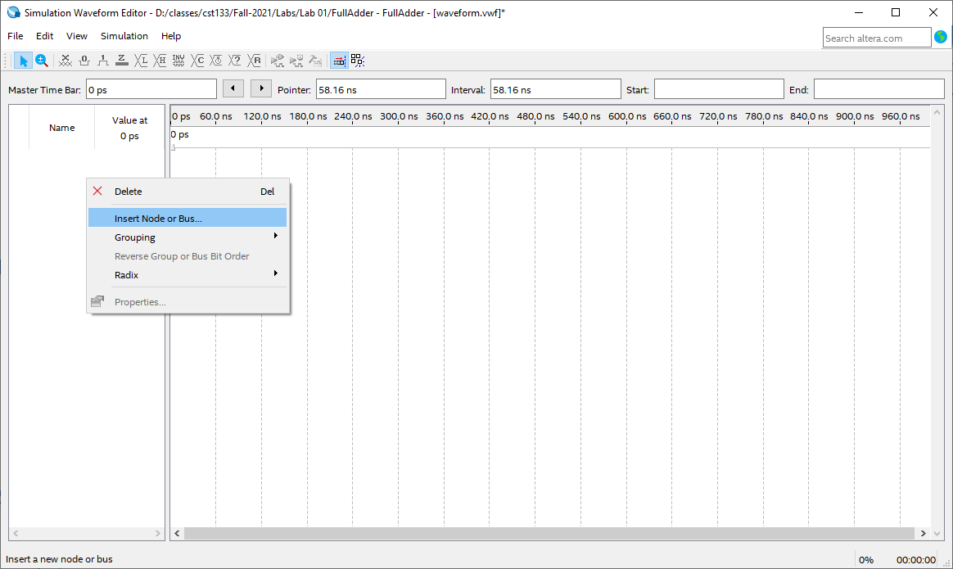
Figure 10 - Insert Node

Now click on the Node Finder button to bring up the Node Finder window as shown in Figure 11.
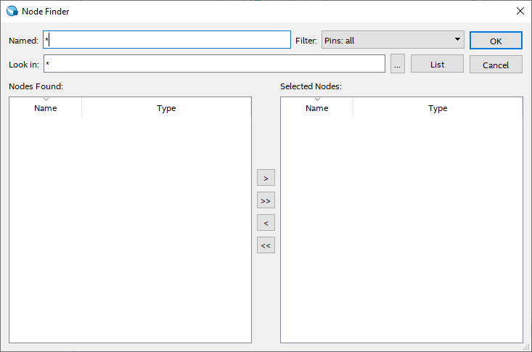
Figure 11 - Node Finder

Next click the “List” button and add the nodes to the waveform window. Overwrite the values for A, B, and Cin as shown in Figure 12.
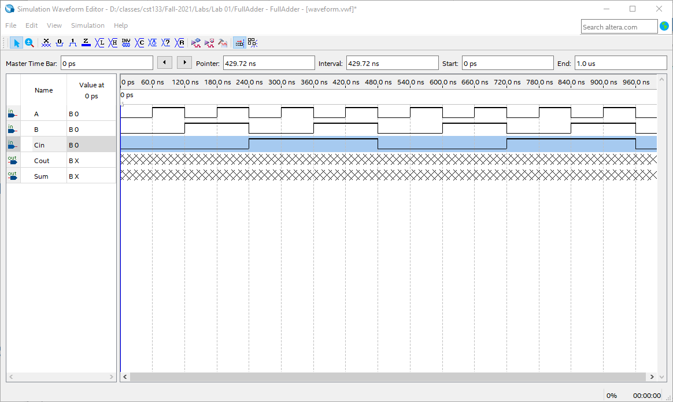
Figure 12 - Input values

Next we will select the Simulation menu and then select “Generate Modelsim Testbench and Script” as shown in Figure 13.
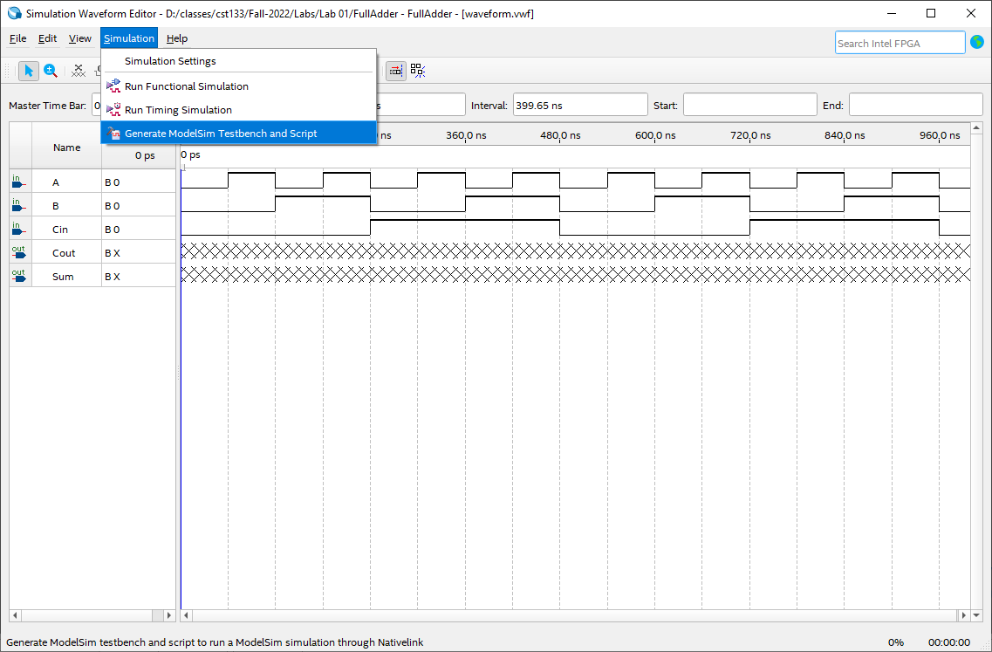
Figure 13 - Generating testbench

Next we need to select the Tools->Options menu in Quartus Prime. We need to make sure that Questa Intel FPGA has a path to where it is installed. Mine is shown in Figure 14. Yours will be under /opt for linux or similar to mine for windows.
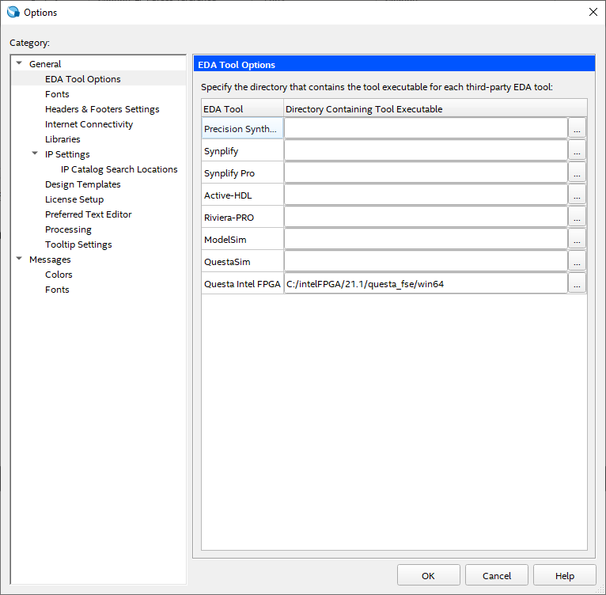
Figure 14 - Quartus Options

Once that has been selected, we need to run the simulation as shown in Figure 15. This will run the Questa Intel Starter FPGA Edition.
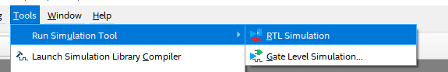
Figure 15 - Run Questa

Before moving to the next step, we need to go to the simulation folder of our project. Move everything from the modelsim folder into the questa folder.

In the Transcript section of Questa type in the following command: do waveform.vwf.do. This is shown in Figure 16.
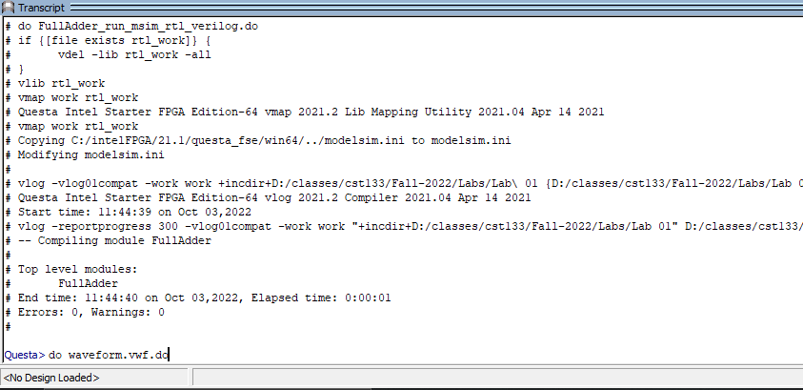
Figure 16 - Running Questa simulation

After zooming out in the wave window you should see your simulation as shown in Figure 17.
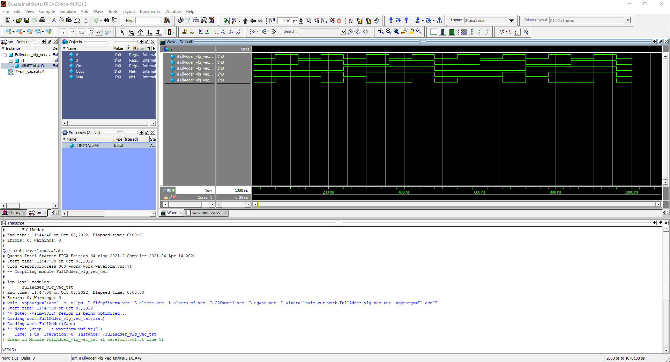
Figure 17 - Questa simulation

Assign Pins and test on board
Using the DE10-Lite user manual assign pins to your inputs and outputs as follows. Input A -> SW0, B -> SW1, Cin -> SW2, Sum -> LEDR0, and Cout -> LEDR1. Recompile your code after the assignments to make them stick and program your board, test, and demo to your instructor.

Submission
For this lab you must submit the following to the course website. Prior to submission the lab must have been demonstrated to the lab instructor.
- Project checked into your Git repository and pushed to the server (make sure you add the lab instructor to your repository for grading your project)
- Project Simulation (Export to PNG/JPG/PDF) in your repository (Project folder. Create a sub directory called images)
- Netlist view for the RTL (Print to PDF) in your repository
- Upload a finished note to canvas (submit text saying you are finished)

